Practical activity: Using a Hoffman Voltameter.
Practical Guide – Hoffman Voltameter

Aim: To use a Hoffman Voltameter to electrolyse water and investigate its composition.
Notes and guidance
This practical involves the use of a Hoffman Voltameter with platinum electrodes. This is expensive and delicate equipment so it is recommended to carry out the procedure as a demonstration.

Once gas has been generated, you may wish to allow students to test for hydrogen and oxygen themselves with wooden splints. If students have not carried out these tests before then you should refresh them on the method beforehand with a demonstration. In all cases, remind students of the dangers of working with fire.

This experiment requires the use of a low voltage power supply. This should be locked so the voltage cannot be turned up to exceed that which is required for electrolysis. Approximately 4V is usually sufficient. If power supplies are not available, battery packs can be used instead.

Speak with your technician colleague in advance of this practical as they may need time to prepare resources. If a Hoffman Voltameter with platinum electrodes is not available, see the ‘alternative methods’ section of this practical guide.

Risk Assessment Notes
A risk assessment must be completed for this practical. The risk assessment should be specific to the class involved and written only by the teaching member of staff. For more guidance refer to CLEAPSS. It is good practice for students to wear safety spectacles during all class practicals and demos.

Ensure that power supplies are locked so they cannot exceed 4V. Liquids should be kept a safe distance from power supplies and any spills should be cleaned up immediately. 2 M sulfuric acid is hazardous. Refer to CLEAPSS hazcards during planning and take care when handling.
Equipment | The Hoffman Voltameter  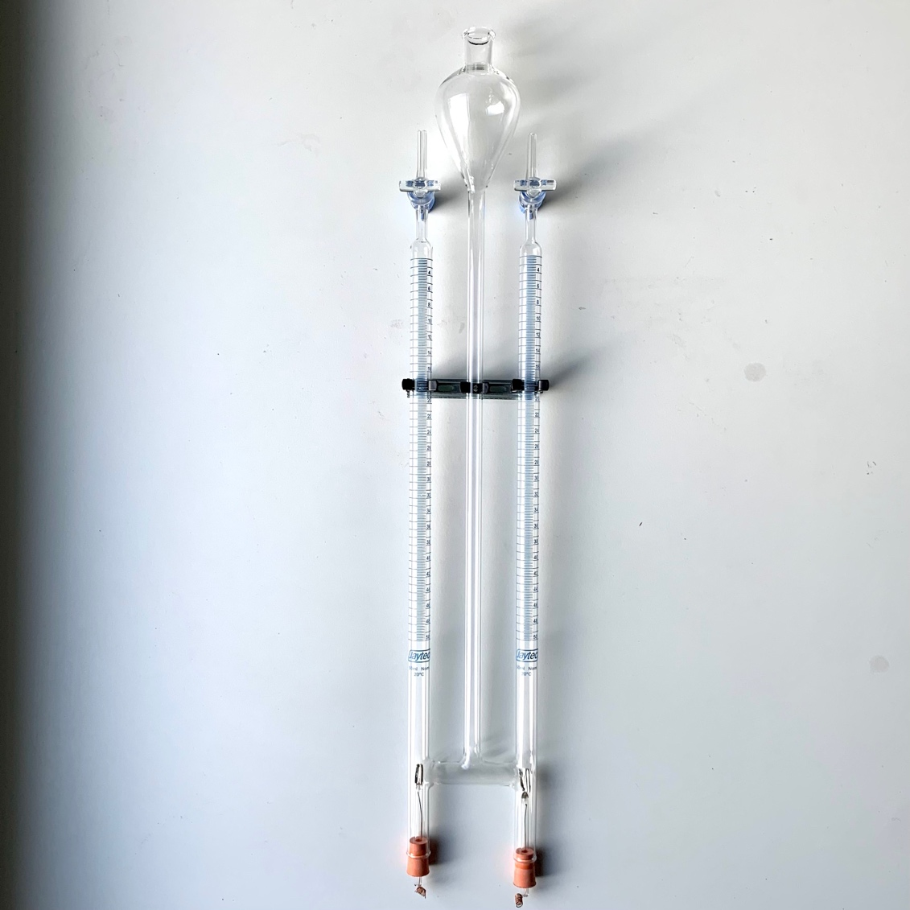
Apparatus:
- Hoffman Voltameter with platinum electrodes
- Stand for the above
- Test tubes and rack
- Splints
- Bunsen burner (or other method of lighting the splints)
- Heat proof mat

Chemicals:
- 2 M sulfuric acid

Method |  | Questions To Ask Students During The Demonstration
- Insert the platinum electrodes and bungs into the bottom of the Hoffman Voltameter  - Connect the electrodes to the power supply – making a note of which is connected to positive and which negative – but do not switch on the power yet  - Pour the 2 M sulfuric acid into the Hoffman Voltameter until it is full  - Ensure the power supply is set to 4 V D.C. and switch it on  - Observe the different rates at which gas is collected on each side of the voltameter  - Once a sufficient amount of gas has been collected, switch the power supply off  - Place a test tube over each side arm and open the taps to fill the test tubes with gas  - Keep the test tube inverted to ensure gas does not escape  - Light a wooden splint and use this to test the gas formed at the negative electrode  - Light and then immediately extinguish a wooden splint. Use this to test the gas at the positive electrode |  | - Why are platinum electrodes used as opposed to the more common and cheaper carbon electrodes? (If carbon electrodes are used, the oxygen generated at the positive electrode can react with the carbon to form carbon dioxide.)  - Why do we use acidified water as opposed to pure water? (Pure water does not conduct electricity and for this process we require an electrolyte. In this case the electrolyte is sulfuric acid.)  - Why is it important to ensure the two electrodes do not touch one another? (This would create a short circuit and no electricity would pass through the aqueous solution.)  - What do you observe about the rates at which gases are generated at the positive and negative electrodes. (Gas is generated at twice the rate at the negative electrode as the positive electrode.)  - What happens to the lit splint when it contacts the gas formed at the negative electrode? (A ‘squeaky pop’ is heard.)  - What does this tell us about the gas? (It is hydrogen.)  - What happens to the extinguished splint when it contacts the gas formed at the positive electrode? (It relights.)  - What does this tell us about the gas? (It is oxygen.)  - Why is twice as much hydrogen as oxygen generated in the same amount of time? (The formula for water is H₂O, which tells us that each molecule of water is made from two hydrogen atoms and one oxygen atom. When electrolysed, the water molecules are broken up and twice as many hydrogen atoms are generated as oxygen atoms.)
Alternative Methods/Computer Simulations |  | Alternative Method Diagram
After testing for hydrogen and oxygen, you can attach rubber tubing to mix the two gases in a 2:1 ratio. When ignited this will make a louder noise than the squeaky pop of the hydrogen test. (It is recommended you trial this before the demonstration as it can be quite dramatic.)  If a Hoffman Voltameter with platinum electrodes is not available, a simpler version of this demonstration can be carried out with a basic electrolysis cell and upturned tubes. If the equipment is available, you may wish to carry out this version as a class practical.  Depending on the equipment available, this version can be fiddly to set up. However, they can still give excellent results as it is clear that the gas at the negative electrode (hydrogen) is generated twice as fast as the gas at the positive electrode (oxygen).  If using small electrolysis cells and ignition tubes, it can be tricky to test the generated gases using this setup. In this case you may wish to demonstrate the tests for hydrogen and oxygen by generating your own with basic chemical reactions such as magnesium and hydrochloric acid (hydrogen) and hydrogen peroxide and manganese oxide (oxygen). This can also serve as a good reminder of previous experiments and reinforce ideas already taught. |  | 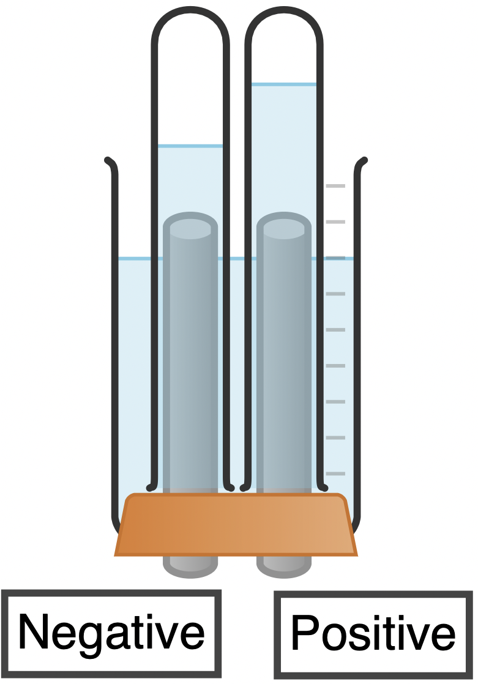
Clearing up
It is important that equipment is returned to the prep room in good order. If safe to do so, rinse used equipment and put it in the used equipment tray. If the trays arrived on a trolley, students must return all trays and equipment to that trolley. Anything dirty needs to be placed into a separate container for washing up. Never put dirty equipment back into a tray with clean equipment.

Hoffman Voltameter
This is an expensive and delicate piece of equipment, it is recommended that this experiment be carried out as a demonstration. See the ‘alternative methods’ section for another approach that can be used if the equipment is not available or if you wish for students to carry out a version of this experiment themselves.

Dedicated electrolysis chambers are available for purchase from many scientific suppliers. These consist of a cylinder of metal that can fit over a two-hole bung with protruding electrodes. The benefit of these is that they require much less solution per experiment, and also allow for easy collection of any gases generated via upturned ignition tubes over each of the electrodes. These are not a perfect alternative for a Hoffman Voltameter, but they can be used in a pinch to show the same principles.

Technician Notes
Ensure the solutions you provide are free from contamination and the equipment is as clean as possible.

Discuss this practical with the class teacher ahead of time. Ensure they have considered the risks of this practical and are confident with the techniques used. If necessary, provide them with the appropriate CLEAPSS so they are comfortable with the chemicals to be used and how to use and dispose of them safely.

Ensure the teacher and the class are fully aware of how expensive and delicate a Hoffman Voltameter with platinum electrodes is.

